**SCIENTIFIC COMMITTEE**

**TWENTY FIRST REGULAR SESSION**

Nuku’alofa, Tonga

13-21 August 2025

**Ecosystem and climate indicators of the western and central Pacific Ocean**

**WCPFC-SC21-2025/EB-WP-01**

**14 July 2025**

Nicholas J Hill1, Pearse Buchanan2*, Christopher Chapman2*, Thomas Moore2*, Joanne Potts1*, Bernadette Sloyan2*, Simon Nicol1

Executive Summary 3

Recommendations 3

Introduction 4

Proposed indicators 8

Indicator 1: Sea surface temperature 8

Indicator 2: Depth of subsurface isotherms (layers of constant temperature) 13

Indicator 3: Volume of the western Pacific warm pool. 14

Indicator 4: Surface chlorophyll concentrations 14

Indicator X: Centre of gravity (COG) of the purse seine fishery 14

Indicator X: Size composition of tunas 20

Discussion 24

References 26

Appendix 1: Terms of reference for adopting ecosystem and climate indicators 31

Appendix 2: Suva ecosystem and climate indicators workshop summary 33

Workshop agenda 33

Workshop participants 36

Contents

# Executive Summary

This Working Paper updates SC21 on progress regarding development of a climate and ecosystem indicators report for the western and central Pacific Ocean (WCPO).

The ecosystem and climate indicator recommendations of SC20 were:

* note the progress towards implementing the SC19 endorsed Ecosystem and Climate Indicators Workplan.
* note the delay in the first expert workshop due to travel disruptions associated with the civil disturbances through May-July in New Caledonia.

This working paper notes that a workshop was successfully held in Suva, Fiji 25-26th November 2024 that brought collaborators together from a range of organisations to inform development of a workplan and indicators.

This paper presents substantial progress of candidate indicators and production of several new indicators outlining their rationale, status and methods. There is also discussion provided detailing whether these indicators meet the established screening criteria. The outputs from this report meet the expected outcomes detailed in the current workplan. It also details a continued workplan that involves refinement of current indicators, exploration of new indicators, potential research, and planning of a second meeting in 2026.

# Recommendations

We invite SC21 to note the results of this updated climate and ecosystem indicators report and present recommendations for future work:

* Note the successful undertaking of a workshop in Suva, Fiji in November 2024 that brought collaborators together from a range of organisations to inform development of a workplan and candidate indicators.
* Note the continued development and refinement of climate and ecosystem indicators for routine updating and presentation to future SC meetings.
* Note the need for continued support of research focused on developing methods that can identify and monitor climate change-related impacts on the WCPO and its associated fisheries.
* Note the updated workplan for ecosystem and climate indicators research for 2025-26.

# Introduction

Ocean change, driven by human forced climate change, and variability is impacting marine ecosystems and their associated fisheries (Antão et al., 2020; Hoegh-Guldberg and Bruno, 2010; Pecl et al., 2017; Poloczanska et al., 2013). This includes impacts such as shifts in the ranges of species and ecosystems (Pecl et al., 2017; Pinsky et al., 2020), changes in species physiology (Agarwal et al. 2024), and in community compositions (Johnson et al., 2011; Poloczanska et al., 2016, 2013). However, how ocean change and variability impacts are manifesting themselves in individual species, ecosystems and fisheries are varied (Garciá Molinos et al., 2017).

The Western and Central Pacific Ocean (WCPO) circulation is a complex system of zonal and meridional currents that redistribute waters in an east-west and north-south direction and vertically between the surface and 500 m (Capotondi et al. 2023, Figure 1).

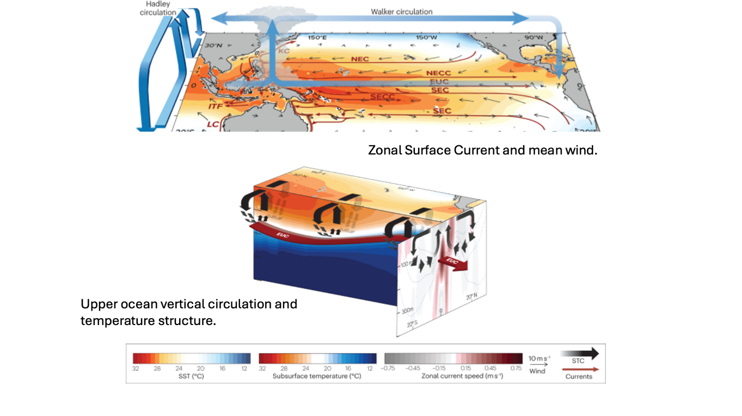Figure 1.Schematic showing the major ocean currents and circulation of the tropical Pacific Ocean. Key features include the westward flowing North and South Equatorial Currents (NEC, SEC), the eastward flowing subsurface Equatorial Undercurrent (EUC), and the North and South Equatorial Counters (NECC, SECC). At the equator, wind-driven Ekman divergence results in upwelling and water is transported off the equator where Ekman convergence results in downwelling, creating shallow overturning circulations in both hemispheres termed subtropical cell (black arrow), known as the Subtropical Cell (STC). (After Capotondi et. al., 2023)

These currents play a crucial role in redistributing ocean temperature, salinity, oxygen and nutrients within the WCPO region (Ganachuad et al, 2014). Thus, trends, and temporal and spatial variability in the Western and Central Pacific Ocean circulation can have an outsized impact on the marine ecosystem and impact the reigonal tuna fisheries.e . Such changes to the oceanstateof the WCPO are typically driven by large-scale climate modes, including the El Niño Southern Oscillation (ENSO) and Pacific Decadal Oscillation (IPO), and overlain upon ocean change driven by climate change. This variability in ocean circulation is not uniform and thus impacts on marine ecosystems are not consistent throughout the WCPO. Therefore, it is essential to understand how climate change and natural variability, and their interactions might shift the oceanographic structure and composition of the WCPO.

The WCPO supports the world’s largest and most valuable tuna fishery in the world (FAO, 2024). A prominent oceanographic feature in this region is the western pacific warm pool which is characterised as a large body of water above 28oC that sits in the tropical WCPO and is the main fishing grounds for the Western and Central Pacific Fisheries Commission (WCPFC) purse seine fishery. The warm pool shifts in size with natural climate variability, namely with ENSO events (Leung et al., 2022; Weller et al., 2016). Tuna and the WCPFC purse seine fishery shift with the warm pool following favourableocean conditions with several tropical tuna species also known to spawn in this region (Lehodey et al., 2020, 2003; Ohashi et al., 2019). With the effects of climate change, predictions suggest an eastward expansion of the western pacific warm pool and with it, an eastward shift in tuna biomass (Bell et al., 2021; Weller et al., 2016). If tuna biomass does shift, this could have flow on effects to Pacific Island countries and territories (PICTs) which are highly dependent on fisheries for food security and as a source of income (Bell et al., 2015; Gillett and Fong, 2023).

In response to climate change, including changes in the frequency and intensity of natural modes of ocean variability, fisheries administrations are increasingly looking at ways to monitor and adapt to its effects (Taylor and Walter, 2024). Within tuna regional fisheries management organisations (RFMOs), climate and ecosystem indicator reports are now being regularly produced to monitor environmental conditions and to track if any underlying shifts in ecosystems, fisheries or species of interest are occurring (Griffiths and Fuller, 2019; Juan-Jordá et al., 2018; SPC, 2023). Since 2015, the WCPFC has produced a series of reports that have explored the development of ocean and ecosystem indicators for the WCPO (Anon, 2015), and a set of candidate indicators have been reported since 2019 at SC15 (Allain et al., 2021, 2020; Juan-Jordá et al., 2019; SPC, 2024, 2023, 2022). Candidate indicators produced thus far have generally been empirical in nature, such as summarising catch and effort location, key environmental variables (e.g. sea surface temperature, ENSO events), and tuna biology (e.g. mean length of catch). However, the empirical nature of many of these indicators can make it difficult to disentangle natural and forced climate variability, changes in fishing behaviour, and any underlying trends.

As part of developing ecosystem and ocean indicators, a workshop was held in Suva, Fiji November 2024 to consider candidate indicators. Details of this workshop are provided in Appendix 2. In summary, this workshop brought together approximately 25 participants both in person and online from a range of organisations including SPC, NOAA, WCPFC, CSIRO, private sector, NGOs and member country representatives. The workshop suggested a number of indicators that represent the current and past state of the Western and Central Pacific Ocean and its fisheries to monitor variability.

### Objectives

The intent of developing an ecosystem and ocean ndicators report is to present a summary of the enviornmental state of the WCPO which will provide the SC with the capability to report on ecosystem and ocean change impacts in its annual reporting to WCPFC. Ultimately, it is the hope that this report will be adopted by the Commission and routinely produced to provide up-to-date information to the SC and WCPFC to help inform decision-making and support its application of an ecosystem-based approach to fisheries management (EAFM). This iteration of the report represents a continuation of this work.

Here, six of the seven proposed candidate indicators are presented for consideration . These include ocean indicators such as sea surface temperature variability and area of the western pacific warm pool as well as several fisheries indicators. Indicators are introduced and provisionally assessed against the SC12 screening criteria detailed in Appendix 1 which required a combination of the indicator being reflective of the current environment, responsive to changes, cost effective, and science-based among others. The candidate indicators presented include:

1. Sea surface Temperature variability, regionally and for EEZ.
2. Depth of selected ocean isotherms and variability from the annual mean state
3. Volume of the pacific warm pool and variability from the mean state
4. Surface chlorophyll concentrations
5. Centre of gravity (COG) of the purse seine fishery
6. Size composition of tunas
7. Oxygen distribution and concentrations changes (not reported, underdevelopment)

Below, a rationale for the inclusion of each indicator is given along with a summary of their status over time and whether they meet the SC12 criteria (Appendix 1). As part of this report, the sensitivity and robustness of some of these candidate indicators will be further evaluated.

# Proposed indicators

## Indicator 1: Sea surface temperature

**Rationale:** Sea surface temperature (SST) is a fundamental driver of tuna biomass distributions due to its influence on physiology and habitat suitability. Tuna species within the Western Pacific are thermophylic and prefer warmer temperatures only offerred by the tropical and subtropical oceanographic provinces (ref). Variations in surface temperature are strongly associated with variations in tuna biomass (ref), as evidenced by the variations observed during El Niño and La Niña events. Skipjack tuna, for example, exhibit clear west to east shifts in biomass during El Niño events as warmer waters spread east and expand their suitable habitat. Furthermore, larval survival and thus recruitment of tuna fisheries is strongly dependent on temperature.

SST in the tropical Pacific is highly variable, in response to the decadal and seasonal cycles, ENSO, ocean circulation and human-induced climate change. Thus, the magnitude of monthly SST and long-term variability differs significantly across the WCPO region. To effectively monitor SST variability, we divide the WCPO into eight(8) large sub-regions based on dominant ocean circulation features (Figure X_SSTregions).

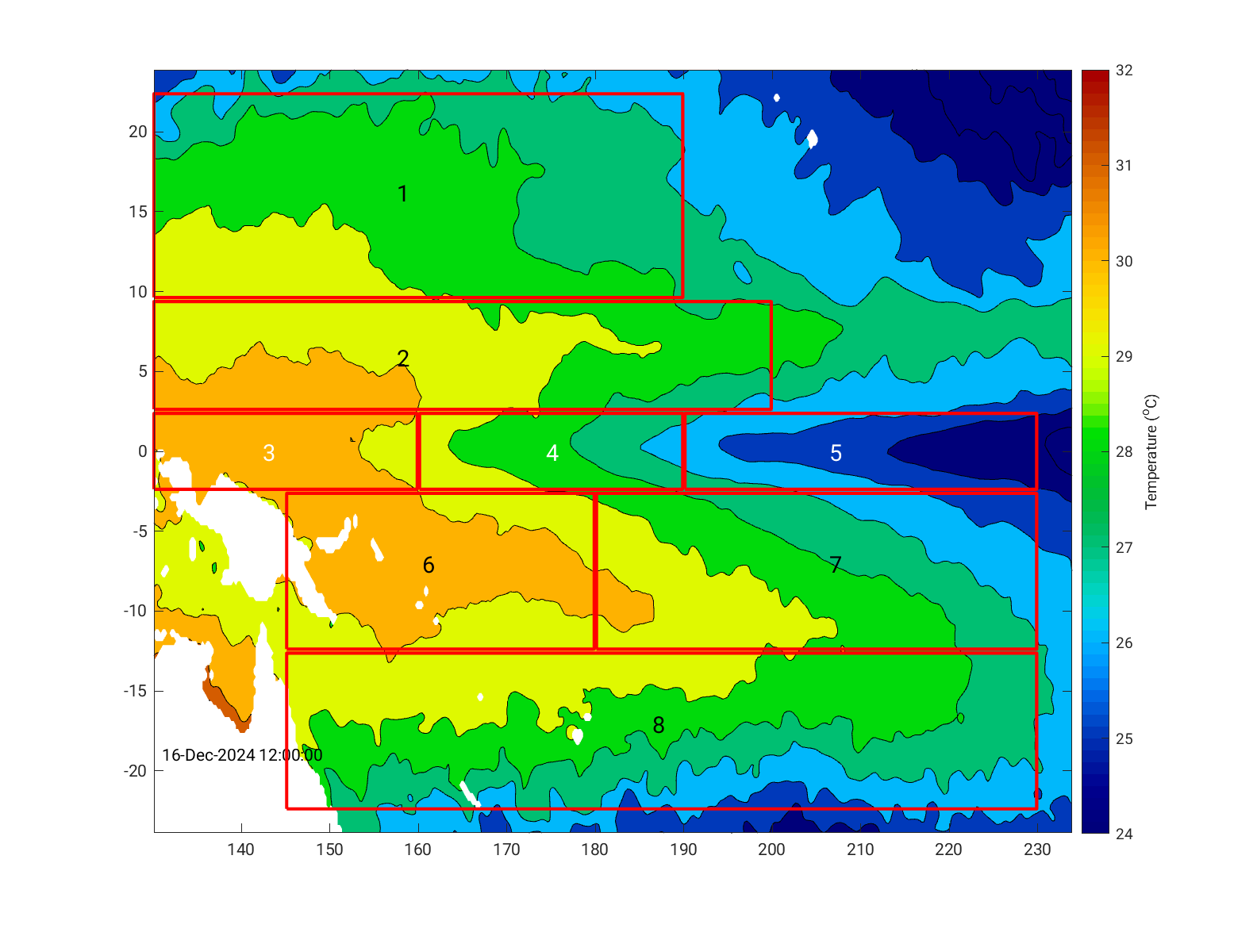

Figure X_SSTregions. The eight (8) SST WCPO regions used to monitor SST and its variability. These regions are: for the north, Region 1 22.5 N-9.5N, 130-190 E, Region 2 9.5N-2.5N, 130-200E; for the Equator Region 3 2.5N-2.5S 130-160 E, Region 4 2.5N-2.5S, 160-190 E, and Region 5 2.5N-2.5S, 190-230 E, and for the south, Region 6 2.5S-12.5S, 145-180 E, Region 7 2.5S-12.5S, 180-230E and Region 8 12.5S-22.5 S, 145-230 E.

Status: *Bernadette and Thomas?...* Monthly SSTs are calculated from the daily NOAA OISST climatology for the period 1982 to March 2025. Monthly SST variability is relative to the climatological mean (1982-2024), variations from the historical mean are presented in Figures X_SSTnorth, X_SSTeq, and x_SSTosuth. These figures show that SST in the northern and southern region of the WCPO, between 22.5-12.5N/S has a clear seasonal cycle. However, through the 1982 to 2025 time period the seasonal cycle is showing the impact of an ocean warming trend. As we move closer to the equator the seasonal cycle and SST variability (Regions 2 and 6) and in the western equator region (Region 3) the warming trend has a superimposed intra-annual cycle of approximately 5-8 years and an increased amplitude of the temperature anomaly. The equatorial regions (Region 4 and 5) and the central Pacific (Region 7) between 2.5 S and 12.5 S, and east of 180 E show the largest SST fluctuations and variability due to the east-west movement of the warm pool along the equator and displacement of warm water off the equator. The ENSO temperature anomalies of Regions 4, 5, and 7 are large, (up to 2.7oC), dominating any climate change trend that may be present.

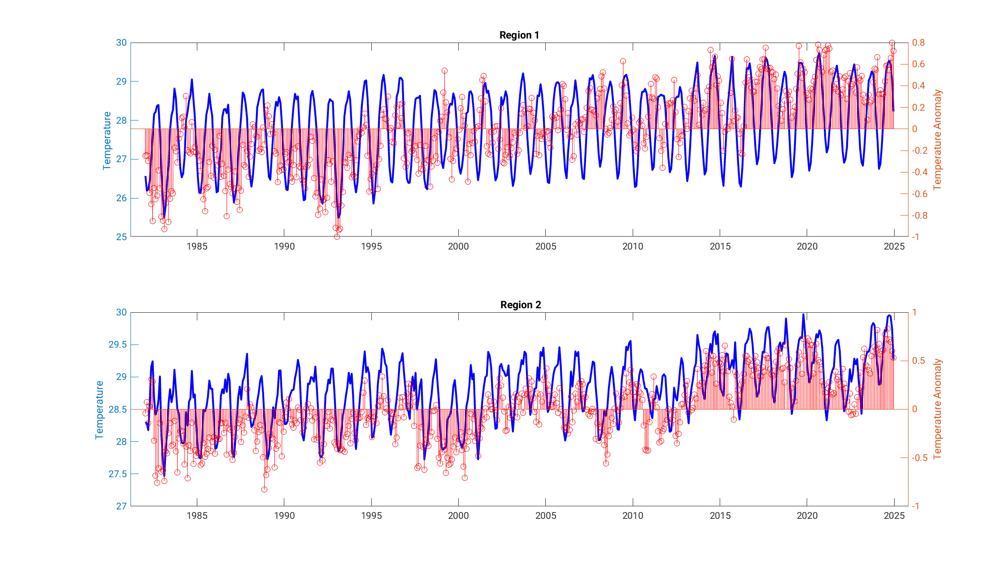Figure X_SSTnorth. Monthly SST (blue curve) and anomalies (red line) for Regions 1 and 2. Note that the temperature and temperature anomaly y-axes vary for each region. See Figure X_SSTregion for the latitude and longitude area for each region.

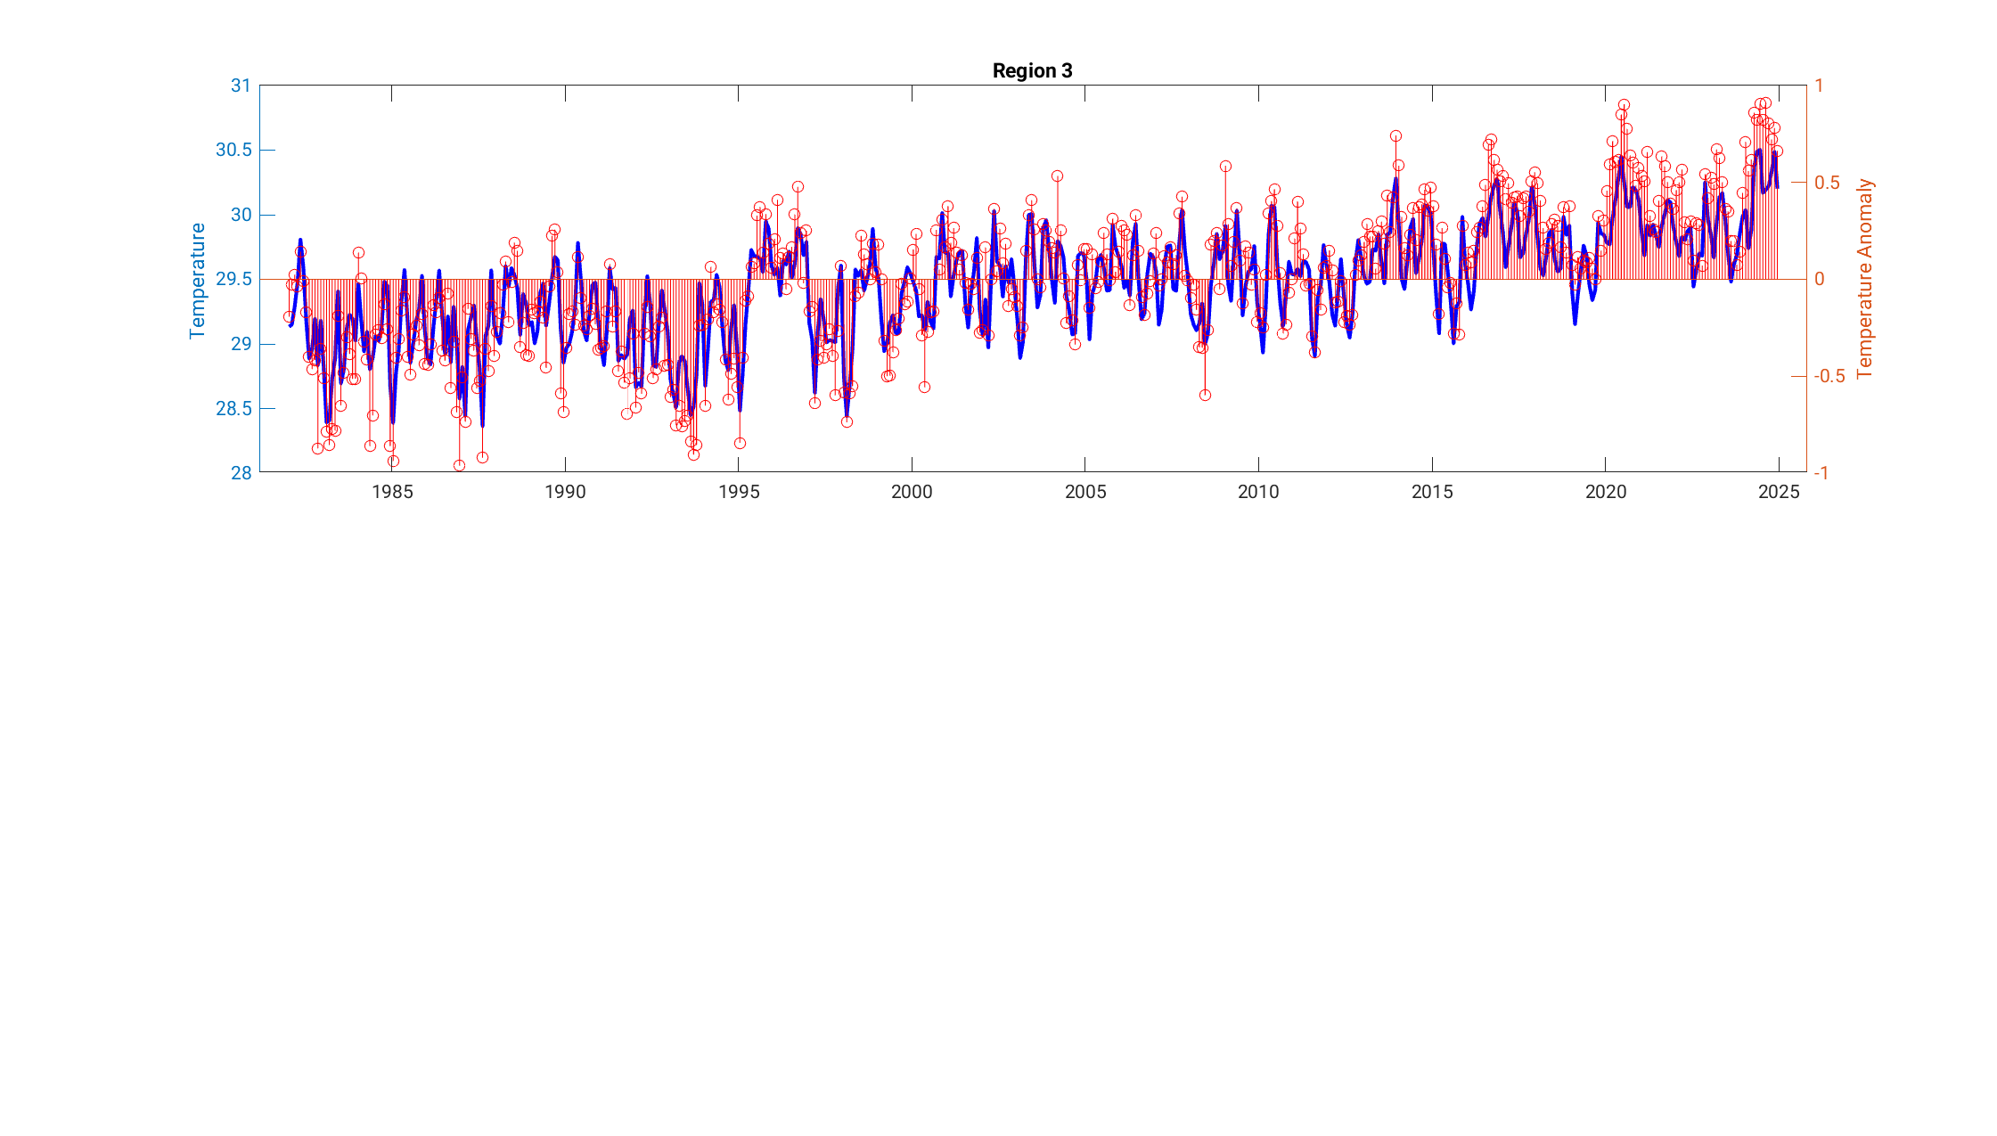

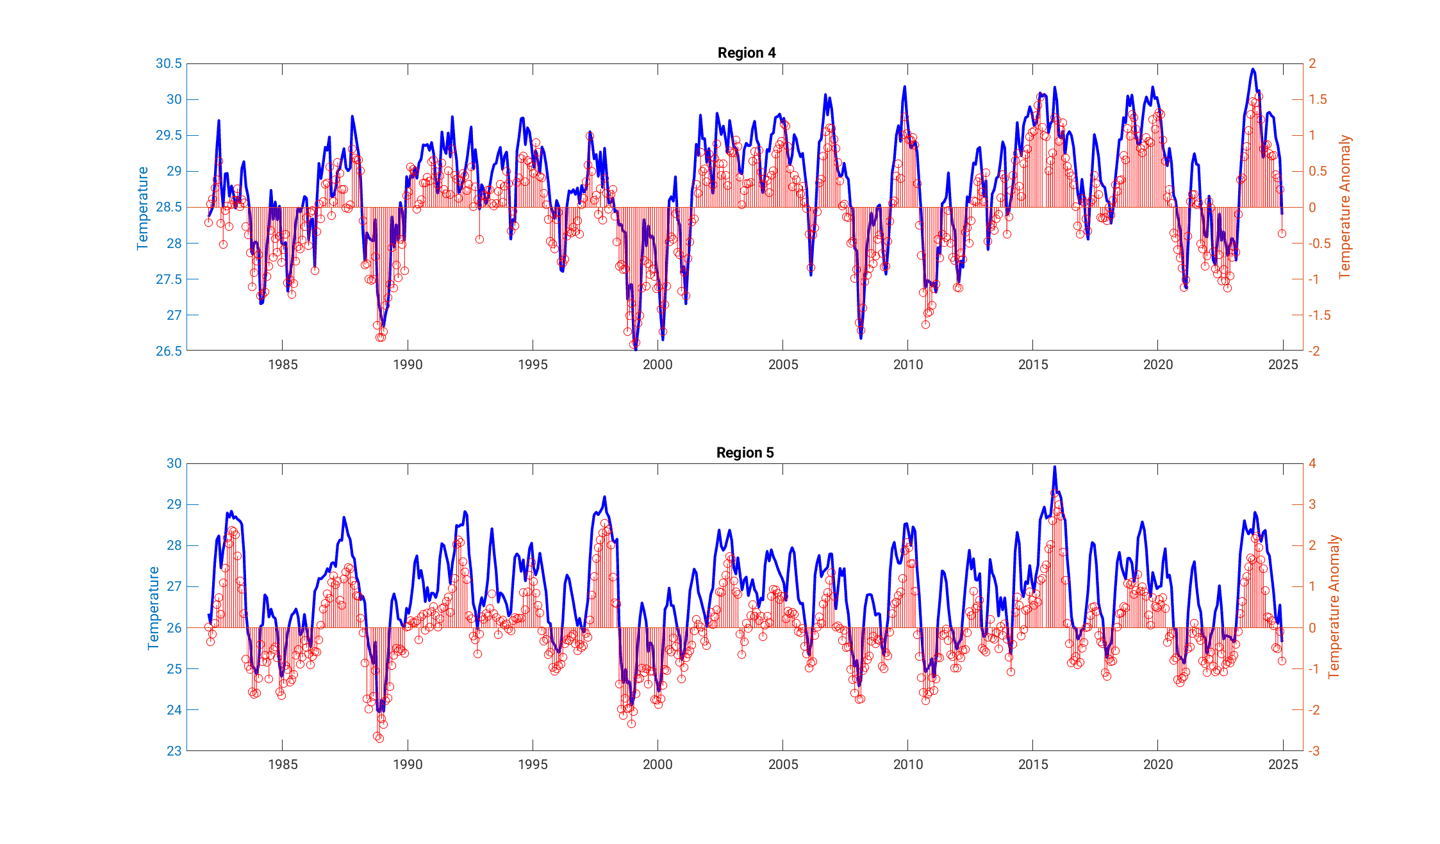

Figure X_SSTeq. Monthly SST (blue curve) and anomalies (red line) for Regions 3, 4 and 5. Note that the temperature and temperature anomaly y-axes vary for each region. See Figure X_SSTregion for the latitude and longitude area for each region.

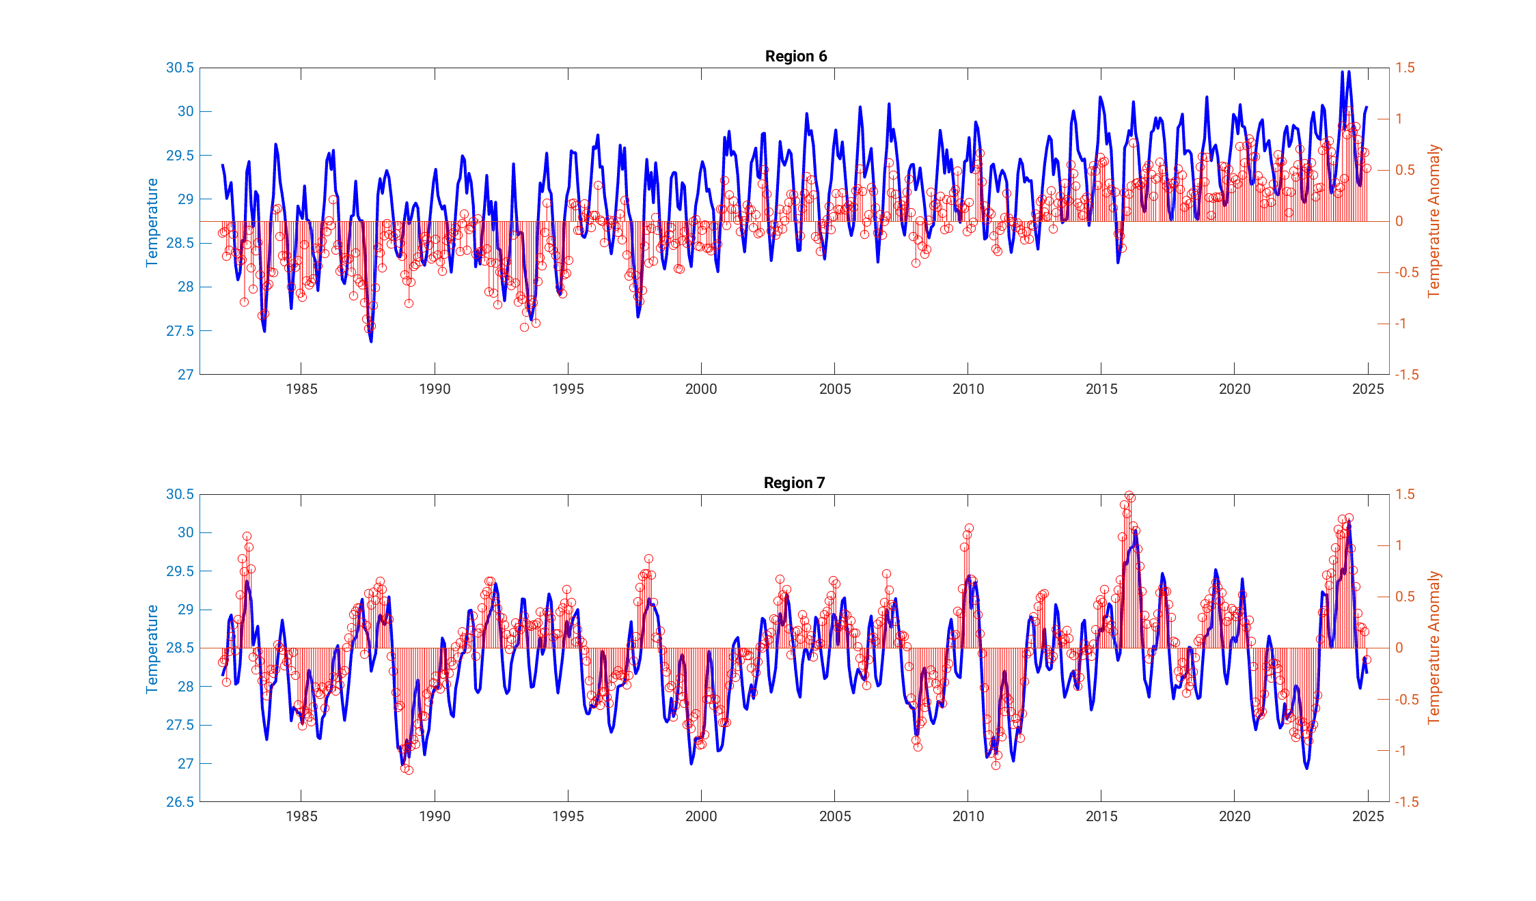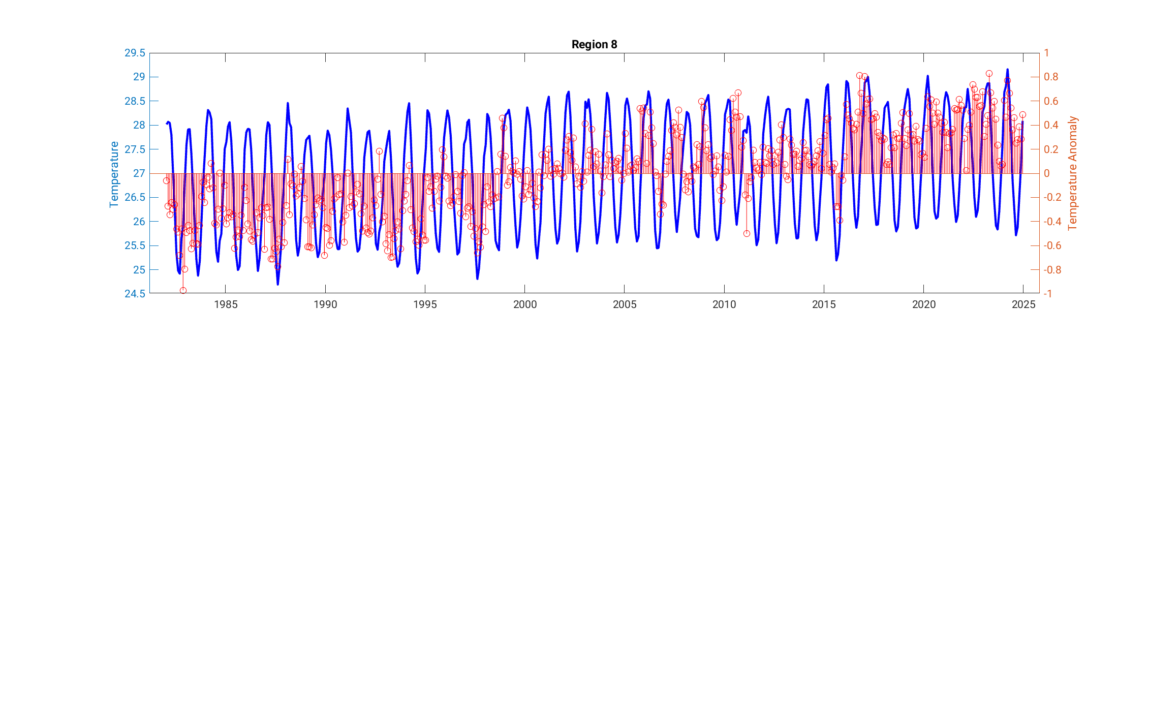Figure X_SSTsouth. Monthly SST (blue curve) and anomalies (red line) for Regions 6, 7 and 8. Note that the temperature and temperature anomaly y-axes vary for each region. See Figure X_SSTregion for the latitude and longitude area for each region.

Description: We use various monthly mean SST climatologies – NOAA OISST (Huang et al. 2021) and EN4.2.2 product (Good et al., 2013) - that combine in situ ocean and satellite observations. OISST available daily on a0.25 x 0.25 These, regularly produced product, are interpolated onto a regular grid and objectively analysed to fill data gaps, providing consistent coverage across the study region. OISST available daily on a 0.25 x 0.25 degree grid, and EN4.2.2 is available monthly on a 1x1 degree grid. For OISST the mean climatology is calculated for the entire time period (1982 to 2025) and anon

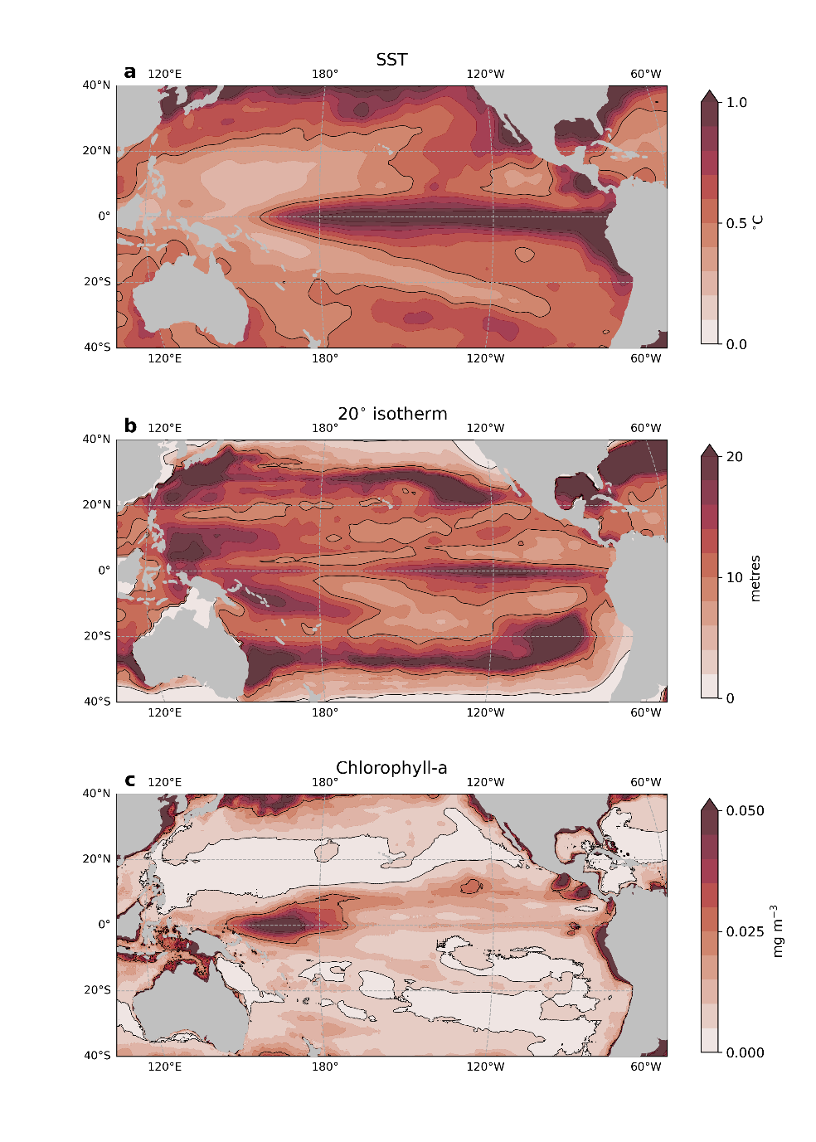

Figure X. Monthly standard deviations in (a) sea surface temperature (SST), (b) the depth of the 20ºC isotherm and (c) the surface concentration of chlorophyll over the past 20 years. Variations are relative to a climatological mean state, so that the values presented here can be interpreted as standard deviations from the mean.

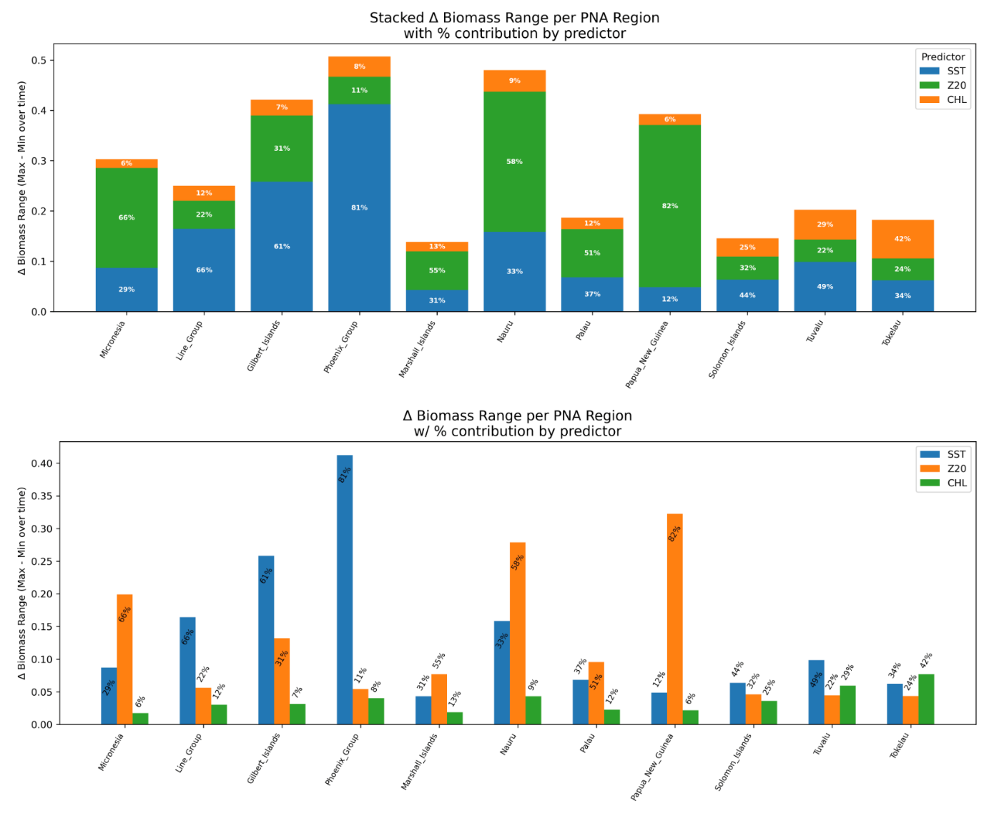

## Indicator 2: Depth of subsurface isotherms (layers of constant temperature)

**Rationale:** Subsurface layers of constant temperature, called isotherms, are useful to delineate the boundaries between oceanographic regimes. The 20ºC isotherm, for instance, defines the boundary between warm and nutrient-poor waters close to the surface from cold, nutrient-rich waters of the deep. Tuna species are thermophylic and are concentrated within the column of water lying above key isotherms. However, tuna species also frequently exploit the boundary between these oceanographic regimes for efficient foraging. Shallower isotherms can therefore represent an elevated prey field made more available closer to the surface, but also less habitat for tuna as their optimal thermal habitat is constrained. During the El Niño phases of the ENSO there is a deepening of isotherms in the central and eastern Pacific, but a shallowing in the west. La Niña conditions cause the opposite.

Status: *Bernadette and Thomas?...*

Description: Using the monthly mean EN4.2.2 product (Good et al., 2013) at approximately 1° horizontal resolution (as described above for SST), we estimate the isotherm depths by regridding the data onto a finer vertical grid (10 metres) and then selecting the closest vertical grid level to the chosen temperature. We only used data starting January 2005, since a step-change in properties occurs as the Argo network comes online to supplement the observation network and biases variability assessments pre-2005.

## Indicator 3: Volume of the western Pacific warm pool.

Rationale: The warm pool is a large, warm body of water at or above 28oC that sits in the equatorial WCPO. The warm pool naturally varies in size and extent, and in particular with ENSO events, which influences where effort and catch consequently occurs in the purse seine fishery Click or tap here to enter text.. The warm pool is also considered as an important spawning ground for tuna species, in particular skipjack tuna and so changes in its size, structure or position may also influence the productivity of tuna Click or tap here to enter text.. With the impacts of climate change, the warm pool is predicted to increase in size, driving a potential eastward shift in tuna biomass Click or tap here to enter text..

## Indicator 4: Surface chlorophyll concentrations

Rationale: Concentrations of chlorophyll are a proxy for phytoplankton biomass, which constitutes the base of marine food webs. While tuna do not prey directly on phytoplankton, these primary producers support the dense aggregations of zooplankton and micronekton that are crucial prey fields for juvenile and adult tuna species. Elevated concentrations of chlorophyll can be detected via satellite, much like sea surface temperature, and so enable a near-real time observational capacity. Such elevations in chlorophyll would indicate the presence of intense upwelling or eddying/frontal activity in the ocean that could represent a region of biomass aggregation for tuna and/or improved recruitment. El Niño events have large impacts on chlorophyll concentrations, with substantial reductions across the western and central Pacific, although these reductions are minimally offset by increases in the far west in proximity to the Maritime Continent.

Description: We used the OCNET product (Hong et al., 2023) from 1st January 2001 to 31st December 2023, which similarly leverages machine learning–based gap‐filling to achieve near‐global coverage. This product is 0.25º horizontal and daily mean resolution, which we regrid to 1° horizontal resolution and monthly means.

## Indicator X: Centre of gravity (COG) of the purse seine fishery

Rationale: The WCPFC purse seine fishery predominately operates in the western pacific warm pool.(Senina et al., 2008)(Ashida, 2020; Fujioka et al., 2024)(Bell et al., 2021; Lehodey et al., 2013)By monitoring the centre of gravity (COG) of purse seine effort and catch, we can potentially monitor if fisheries are responding to these predicted changes and by proxy tuna dynamics. Any shift in the location of the purse seine fishery is also relevant as it relates to income for PICTs when fishing occurs within their EEZ.

Status: For effort, there is a clear distinction in trends over time by set type in COG (Figure 1). For unassociated sets, effort COG shows interannual variability but no clear underlying trend from 1990-2023. In contrast, there is an eastward shift in the COG of drifting FAD-associated sets over time. It appears that the increased uptake of FAD-associated fishing has contributed to trends in the eastward shift in purse seine effort over time. It is difficult to determine if this is a climate related shift in the warm pool and tuna dynamics, or if it is a shift in fishing behaviour with different trends across set type, as well as ENSO events. This is apparent with the large amount of overlap in spread of COG estimates across years.

For catch, there are similar trends in COG, with variable trends across species (Figure 2). Bigeye tuna (BET, *Thunnus obesus*) shows an eastward shift over time, whereas for skipjack tuna (SKJ, *Katsuwonus pelamis*) and yellowfin tuna (YFT, *Thunnus albacares*) it is difficult to determine if a shift is occurring or if it is underlying natural variability. As with effort, it is difficult to disentangle shifts in tuna catch and changes in fishing behaviour to explain these underlying trends with large amounts of overlap in spread of COG estimates across years.

To disentangle the effects of these variables (e.g. set type, ENSO) on purse seine COG over time, the longitudinal distribution of purse seine effort was modelled accounting for a number of these variables. The results of this analysis are summarised in Figure 3 comparing outputs from the analysis with COG indices of effort (for longitude only). In summary, generalized additive models (GAMs) were applied to SBEST purse seine effort data in R using the package ‘*mgcv*’, modelling longitude as function of several variables known to influence effort including month, set type, flag and ENSO event (R Core Team, 2024; Wood, 2011). Outputs from this model showed a variable trend in longitude over time with no clear signal, and with vessel flag having a large effect. It was also apparent from this analysis that different flagged vessels behave differently within the fishery, with some flexibly fishing throughout the convention area while others consistently fish similar regions each year. This suggests that if climate change does affect the distribution of tuna, some vessels and flags will be more susceptible to these changes than others. However, currently it appears that COG cannot reliably detect a climate signal given the magnitude of inherent variability in the data and fishery due to other variables such as set type and flag. Therefore, this indicator may not meet criteria four from the SC12 criteria which requires the indicator to be responsive and with minimal time lags (Appendix 1).

Description: Best estimates of total purse seine catches of BET, YFT and SKJ were used to determine the COG of catch, and best estimates of effort by set type for the COG of effort. Data used were extracted from SBEST databases using raised (aggregated) 1x1 degree purse seine fishery data where set type information was available. Catch and effort were constrained to WCPFC regions 6-8 (latitude: -20oS – 10oN, longitude: 140oE – 210oE) and from years 1990-2024 (Vidal et al., 2020). Catches and effort from domestic Indonesian, Vietnamese, and Philippines flagged vessels were not considered given differences in vessel class and fishing strategy. Associated purse seine sets were considered as sets made on drifting FADs only, floating objects and anchored FADs were not considered in this analysis. The COG is an annual estimate of the weighted mean position of catch and effort where the number of sets is used to weight the effort COG, and catch to weight the catch COG by species. Ellipses of spatial variance (inertia ellipses) were computed alongside the center of gravity (COG) to quantify the spatial dispersion and orientation of fishing effort and catch. These ellipses were derived from the weighted covariance matrix of fishing locations and extracted using the ‘*RGeostats*’ package (Renard et al., 2023).

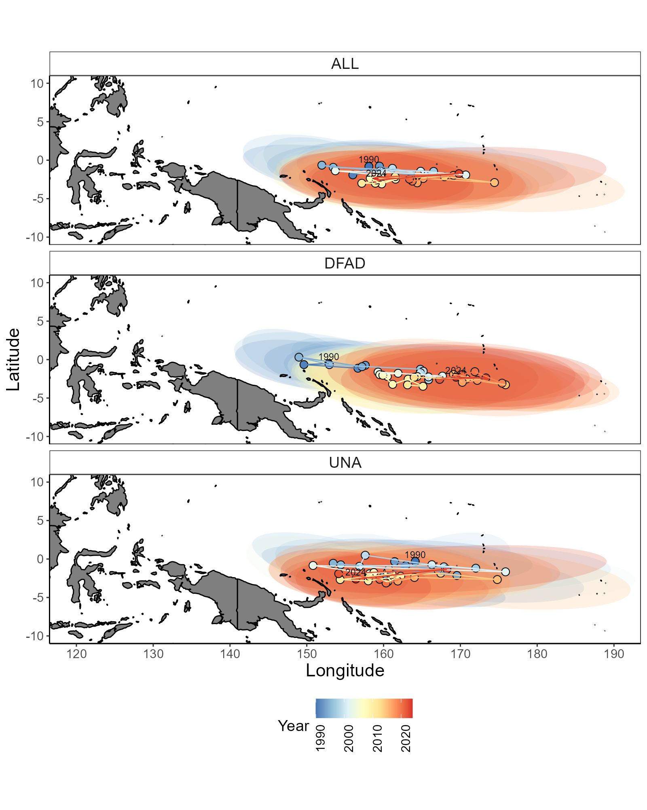

Figure 1: Centre of gravity of WCPFC purse seine effort by set type with ellipses as a measure of spread: all sets (ALL), drifting FAD-associated sets (DFAD), and free-school unassociated sets (UNA) from 1990-2024.

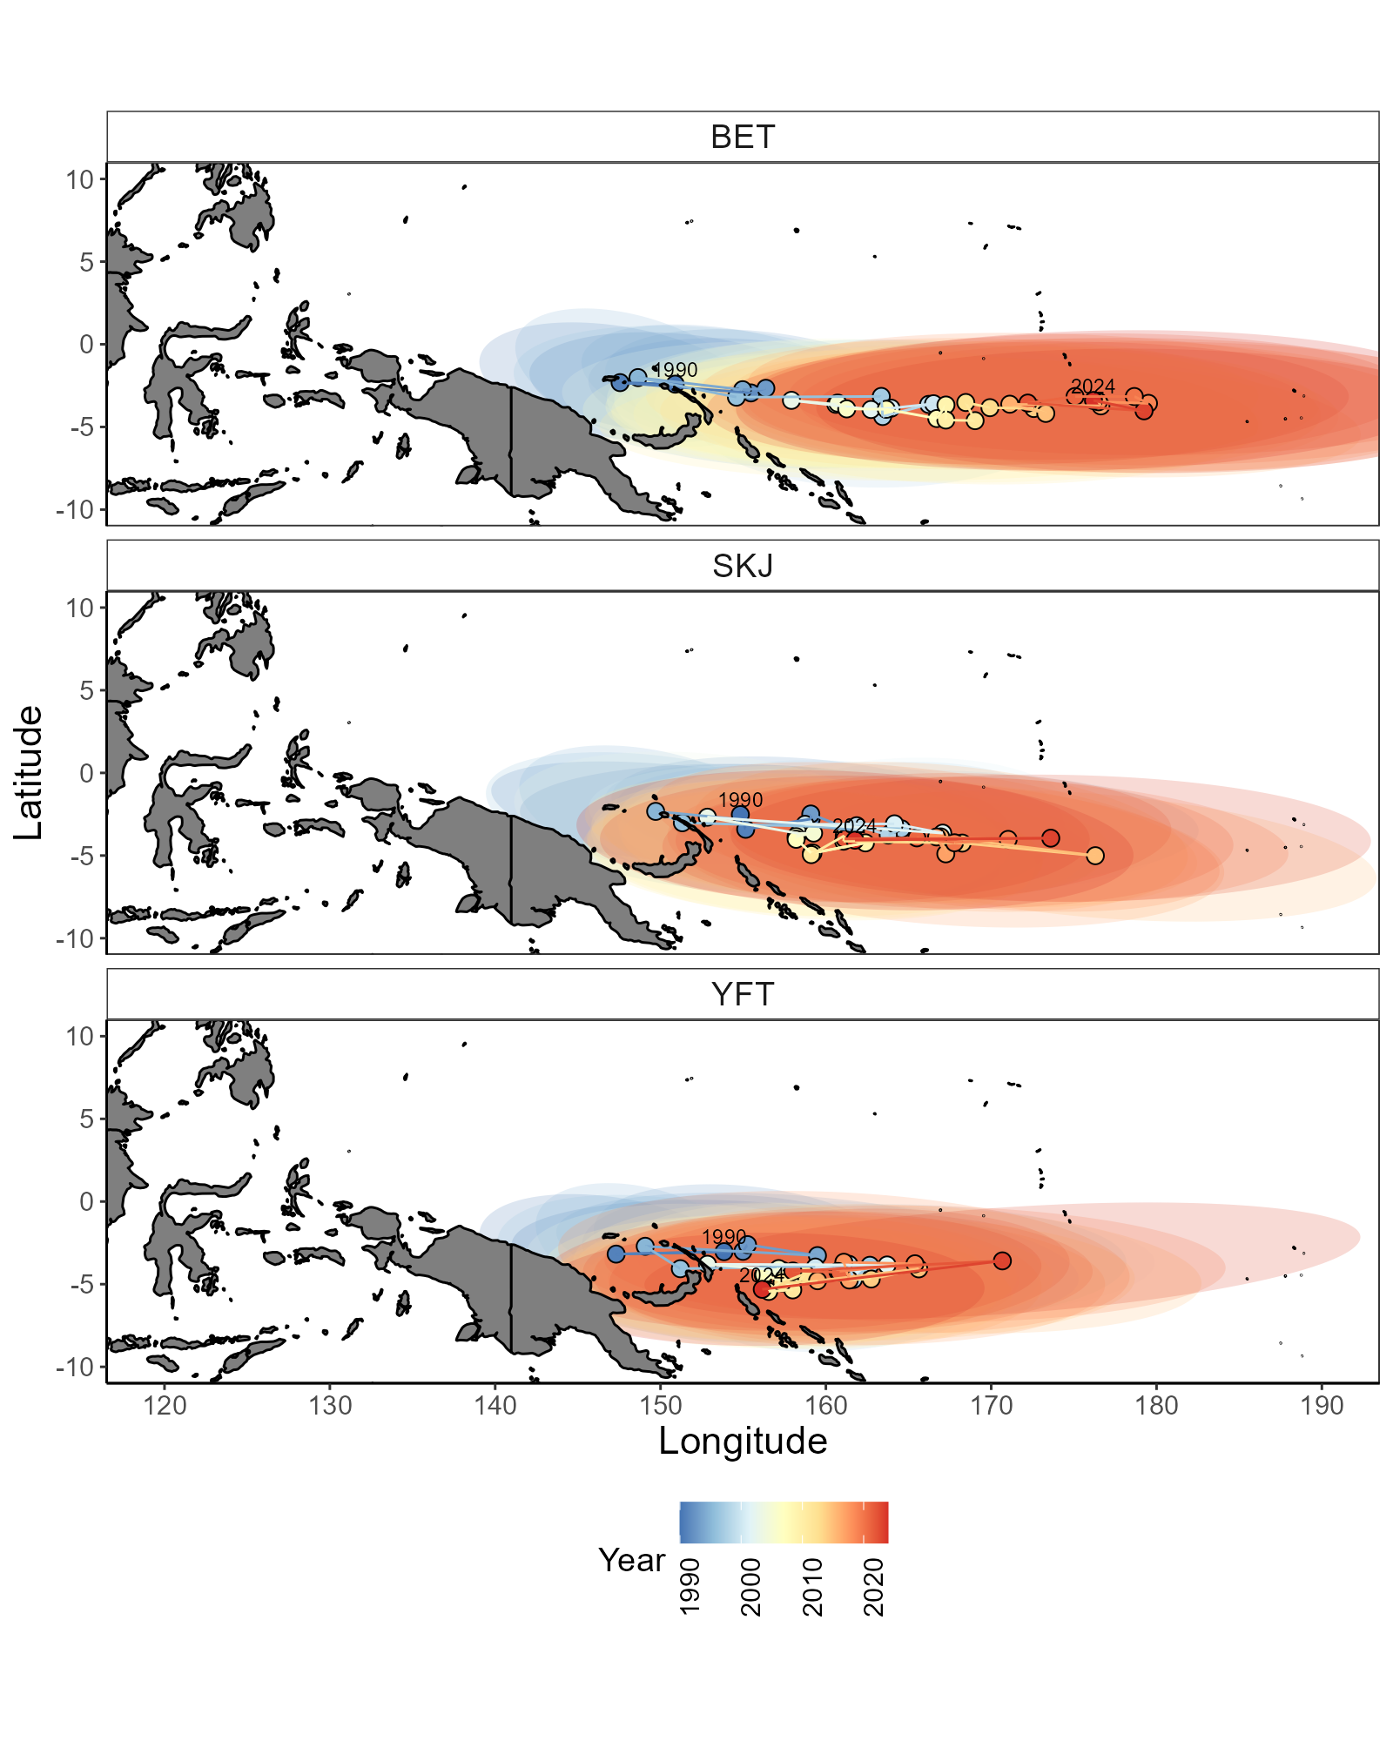

Figure 2: Centre of gravity of WCPFC purse seine catch of bigeye tuna (BET), skipjack tuna (SKJ), and yellowfin tuna (YFT) from all purse seine sets from 1990-2024 with ellipses as a measure of spread.

Figure 3: Comparison of indices used to monitor the longitudinal distribution of the WCPFC purse seine fishery from 1990-2023. Black = modelled longitude. Red = unstandardised mean longitude of effort. Blue = COG of catch. Green = COG of effort. Dashed black = mean longitude from 1995-2005.

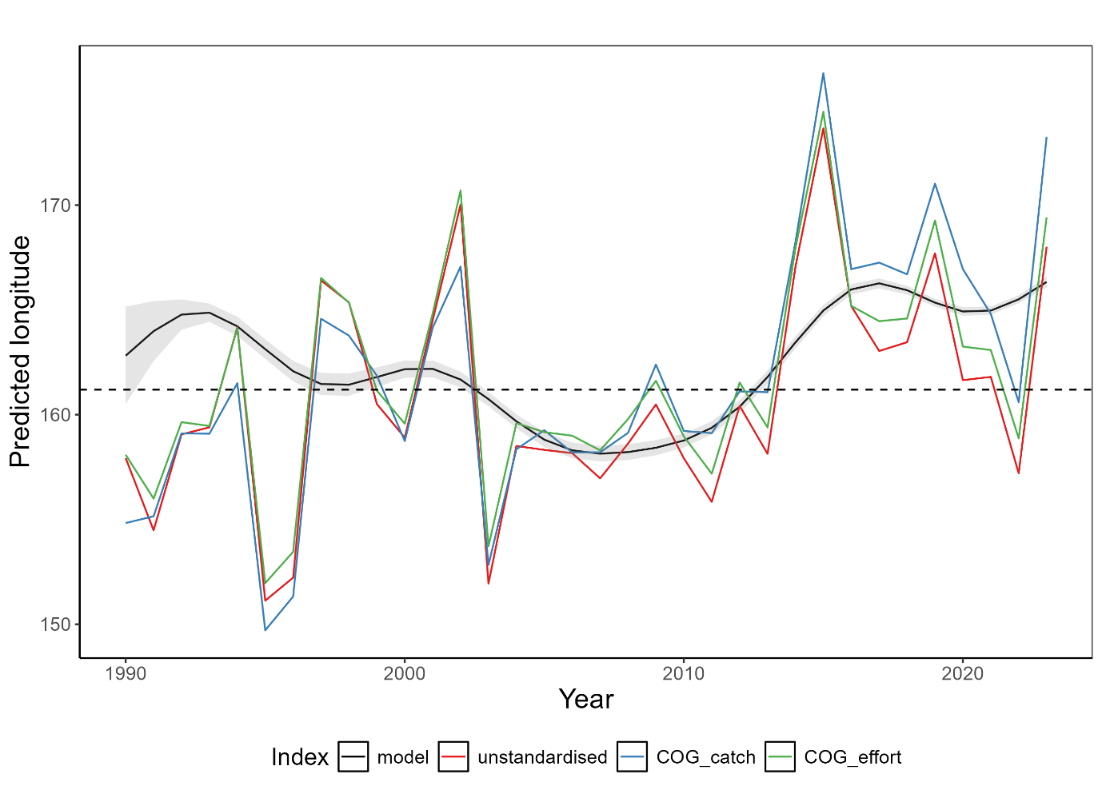

## Indicator X: Size composition of tunas

Rationale:The size composition of a fish population is influenced by a range of factors including fishing and its environment. For example, changing oceanographic conditions could influence prey availability or recruitment having knock-on effects on fish size composition. How the environment and climate change is influencing tuna size composition is not well known. However, by monitoring tuna size composition, any changes can be identified which can help determine sustainability of the fishery and inform management decisions.

Status:Trends in the size composition of tunas has varied from 1990-2023 and there are no clear trends (Figure 4; Figure 5). This is likely a reflection of several factors including changes in sampling design, fishing strategy, and the underlying environment and populations.

For bigeye tuna (BET), their size composition has fluctuated over time rising to values above the 1990-2000 historical mean of 120cm from 2007-2012 before declining to approximately 2018. In recent years, length composition has increased and the mean length in 2024 of 120.9cm is slightly above the historical mean. Throughout this time, most BET catches in the longline fishery have been above the length at 50% maturity of 103cm (Farley et al., 2017). There has been a minor upward trend in the proportion of small fish caught (<106cm), and a decrease in the proportion of large fish caught (>144cm) throughout the timeseries (Figure 5). However, this trend is variable, and recent years have shown a shift in the opposing direction.

For SKJ, their size composition has been more variable which is likely a reflection of fishing and sampling programs. In recent years, SKJ size composition has been at or near the long term near, with the 2024 mean length of 55.2cm slightly above the historical mean of 52.7cm. Unlike YFT and BET, catches have predominately been below the length at 50% maturity of 55cm which is likely due to most catch and sampling coming from the purse seine fishery (Ohashi et al., 2019).

For YFT, a decline in their size composition since 2012 is apparent. From 2000-2010, they show a similar trend to BET where their size composition declined in the early 2000s before rising around 2010. However, in contrast to BET their size composition has since declined and consistently remained below the historical mean value of 118.8cm since 2012, with a 2024 mean length of 113.4cm. Like BET, most of the size composition remains above the length at 50% maturity of 105cm (Magnusson et al., 2023). In terms of length proportions, there has been an increase in the proportion of small fish caught, and a slight decrease in the number of large fish caught.

There is no evidence of an underlying climate trend in the length composition of tunas over time. Given the empirical nature of this indicator, it remains difficult to disentangle a range of variables that are likely to influence the size composition of tunas such as the resolution and robustness of input data, changes in fishing pressure and strategy, natural environmental variability and so on. Further, empirical length indicators are generally not considered responsive to population level shifts in abundance and thus are not likely to be an appropriate indicator. It is unlikely that this indicator can reliably detect a climate signal and therefore, may not meet criteria four from the SC12 criteria which requires the indicator to be responsive and with minimal time lags (Appendix 1).

Description:Length composition data for the three tuna species were extracted from observer and port sampling programs from SPC databases for the years 1990-2024. Longline data were used for BET and YFT, and a combination of longline and purse seine data for SKJ. Where required, total (or other) lengths were converted to fork length measurements using well established conversion factors (Macdonald et al., 2023, 2022). Any outliers in the data were removed and length composition metrics extracted. This included estimating a centered, three-year rolling mean of: 1) small fish: the percentage of fish that were below the 20th percentile of fish sampled from 1990-2000, 2) mean fish: the percentage of fish above the mean length of fish sampled from 1990-2000, and 3) big fish: the percentage of fish above the 80th percentile of fish sampled from 1990-2000. By monitoring these three indicators rather than just the mean length, an improved understanding of a species size composition is gained.

Figure 4: Length composition (cm) of bigeye tuna (BET), skipjack tuna (SKJ), and yellowfin tuna (YFT) in WCPFC longline fisheries (plus purse seine for SKJ) from 1990-2024. Dashed line = mean length from 1990-2000, dotted line = length at 50% maturity. Black dot = mean length with 25th-75th percentile error bars.

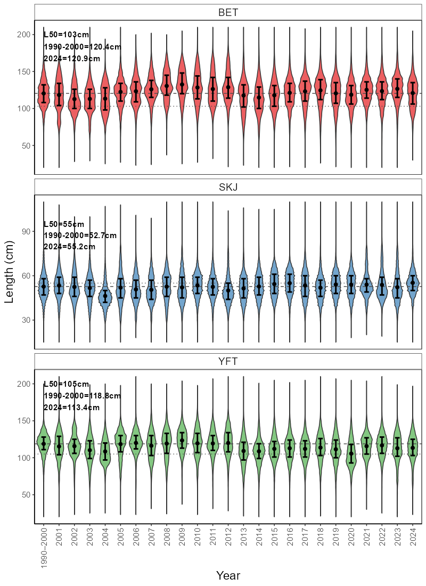

Figure 5: Length indicators for bigeye tuna (BET), skipjack tuna (SKJ), and yellowfin tuna (YFT) in WCPFC longline fisheries (plus purse seine for SKJ) from 1990-2024. Blue = % of fish below the 20th percentile measured from 1990-2000. Red = % of fish above the mean length measured from 1990-2000. Green = % of fish above the 80th percentile of fish measured from 1990-2000. Dashed lines represent linear models fit to each line to get a general trend line.

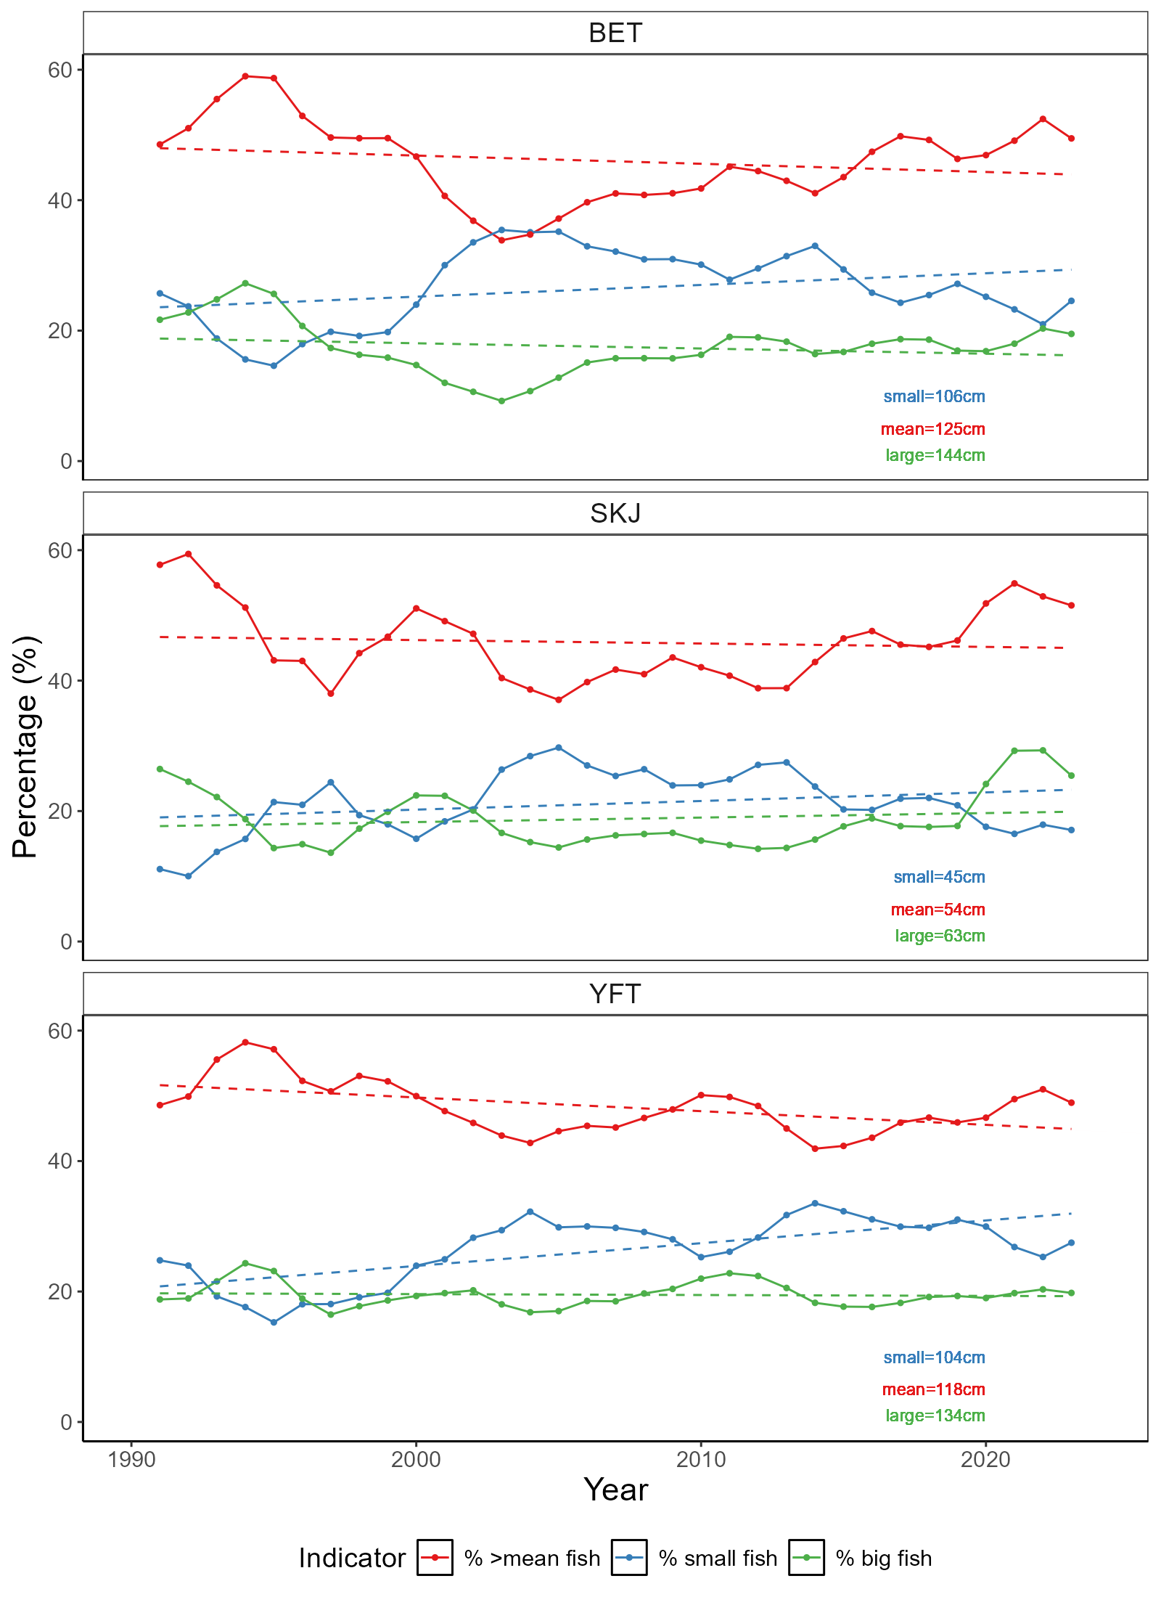

# Discussion

This report presents the continued development and exploration of ecosystem and ocean climate indicators for the WCPFC. The process of developing and selecting indicators is ongoing and is likely to evolve over time. In this report, six candidate indicators have been presented to complement those first three proposed in the SC19 report (Table 1). Several new ocean climate indicators were produced that provide a more complete outlook of the major oceanographic features of the WCPO to be monitored over time. These indicators will require continued development and refinement, but their identification represents an important step forward. Two fishery indicators explored in previous SC reports were also updated and further examined herein. Although providing information and trends on WCPFC fisheries over time, underlying and inherent variability in these indicators likely renders them unresponsive as a climate indicator.

For the ocean climate indicators,…

For the fishery indicators explored here, it is not clear that either would be able to identify an underlying climate signal and therefore may not meet criteria four in relation to being responsive to climate and fishing pressure-related changes (Table 1). This is due to the fishery dependent nature of these indicators and their input data, making it difficult to disentangle a range of other variables (e.g. fishing strategy, data collection programs, flag) that influence these indicators. These fishery indicators do meet several of the other criteria and characterise trends in the WCPFC fishery well, and so may be more appropriate in other reports such as the Tuna Fisheries Assessment Report (Hare et al., 2024). For indicators derived from fisheries data to meet these criteria in the future may require indicators to be modelled to remove the effect of some of these variables, or alternate data sources explored. Preliminary modelling was used to explore both the COG and length composition indicators in this report, and confirmed that these indicators are being influenced heavily by other underlying variables.

Table 1: Performance of proposed indicators relative to SC12 screening criteria which can be found in Appendix 1 of this report. *Proposed indicators presented from SC19.

|  |  |  |  |  |  |  |  |  |  |
| --- | --- | --- | --- | --- | --- | --- | --- | --- | --- |
| **Indicator** | **SC12 Criteria** | | | | | | | | |
| **1** | **2** | **3** | **4** | **5** | **6** | **7** | **8** | **9** |
| *ENSO variability\** | ✓ | ✓ | ✓ | ✓ | ✓ | ✓ | X | ✓ | ✓ |
| *Ocean productivity\** | ✓ | ✓ | ✓ | ✓ | ✓ | ✓ | X | ✓ | ✓ |
| *Warm pool area/volume\** | ✓ | ✓ | ✓ | ✓ | ✓ | ✓ | X | ✓ | ✓ |
| Sea surface temperature variability | *✓* | *✓* | *✓* | *✓* | *✓* | *✓* | *✓* | *✓* | *✓* |
| Depth of isotherm | ✓ | ✓ | ✓ | ✓ | ✓ | ✓ | ✓ | ✓ | ✓ |
| Area/Volume of western pacific warm pool | ✓ | ✓ | ✓ | ✓ | ✓ | ✓ | ✓ | ✓ | ✓ |
| Depth of oxycline | ✓ | ✓ | ✓ | ✓ | ✓ | ✓ | ✓ | ✓ | ✓ |
| Centre of gravity of purse seine fishery | ✓ | ✓ | ✓ | X | ✓ | ✓ | ✓ | ✓ | ✓ |
| Size composition of tunas | ✓ | ✓ | ✓ | X | ✓ | ✓ | ✓ | ✓ | ✓ |

At SC19 (SPC, 2023), three candidate indicators were proposed including ENSO variability, ocean productivity, and warm pool area. These were found to meet all criteria except for criteria seven which relates to the ability of the indicator to be scalable to national and sub-regional scales. Ocean productivity was not updated herein, but could be further explored in the future. The warm pool area indicator was updated and has been explored in a way that can be communicated at national scales potentially overcoming this issue.

Work plan paragraph…

We invite SC21 to note the progress made on the exploration, development and testing of candidate ecosystem and climate indicators for the WCPO. Since SC20:

* A successful workshop was held in Suva, Fiji in November 2024.
* Several new candidate indicators have been developed, and several proposed fishery indicators have been further explored and tested against the screening criteria.
* The workplan detailed in previous SC reports is being upheld and updated.
* Activities for 2025-26 workplan include:
  + Continued refinement of the ocean climate indicators proposed here.
  + Continued exploration of modelled fishery indicators.
  + Continued development of methods to remove biases in earth system models and detrending of climate change to commence analyses that can attribute impacts to greenhouse gas emissions.
  + Organisation of a workshop to be held in 2026.
  + RFMO cooperation/collaboration…

# References

Allain, V., Hare, S., Macdonald, J., Machful, P., Nicol, S., Phillips, J.S., Portal, A., Vidal, T., Williams, P., 2021. WCPO Ecosystem and Climate Indicators from 2000 to 2020. WCPFC Scientific Committee 17th Regular Session, WCPFC-SC17-2021/EB-IP-09, Online.

Allain, V., Macdonald, J., Nicol, S., Phillips, J.S., Vourey, E., 2020. Ecosystem and climate indicators for consideration within the WCPO. WCPFC Scientific Committee 16th Regular Session, WCPFC-SC16-2020/EB-IP-07, Online.

Anon, 2015. Summary Report: Commission for the Conservation and Management of Highly Migratory Fish Stocks in the Western and Central Pacific Ocean. WCPFC Scientific Committee 11th Regular Session, Pohnpei.

Antão, L.H., Bates, A.E., Blowes, S.A., Waldock, C., Supp, S.R., Magurran, A.E., Dornelas, M., Schipper, A.M., 2020. Temperature-related biodiversity change across temperate marine and terrestrial systems. Nat Ecol Evol. <https://doi.org/10.1101/841833>

Ashida, H., 2020. Spatial and temporal differences in the reproductive traits of skipjack tuna Katsuwonus pelamis between the subtropical and temperate western Pacific Ocean. Fish Res 221, 105352. <https://doi.org/10.1016/j.fishres.2019.105352>

Bell, J.D., Allain, V., Allison, E.H., Andréfouët, S., Andrew, N.L., Batty, M.J., Blanc, M., Dambacher, J.M., Hampton, J., Hanich, Q., Harley, S., Lorrain, A., McCoy, M., McTurk, N., Nicol, S., Pilling, G., Point, D., Sharp, M.K., Vivili, P., Williams, P., 2015. Diversifying the use of tuna to improve food security and public health in Pacific Island countries and territories. Mar Policy 51, 584–591. <https://doi.org/10.1016/j.marpol.2014.10.005>

Bell, J.D., Senina, I., Adams, T., Aumont, O., Calmettes, B., Clark, S., Dessert, M., Gehlen, M., Gorgues, T., Hampton, J., Hanich, Q., Harden-Davies, H., Hare, S.R., Holmes, G., Lehodey, P., Lengaigne, M., Mansfield, W., Menkes, C., Nicol, S., Ota, Y., Pasisi, C., Pilling, G., Reid, C., Ronneberg, E., Gupta, A. Sen, Seto, K.L., Smith, N., Taei, S., Tsamenyi, M., Williams, P., 2021. Pathways to sustaining tuna-dependent Pacific Island economies during climate change. Nat Sustain 4, 900–910. <https://doi.org/10.1038/s41893-021-00745-z>

Capotondi, A., McGregor, S., McPhaden, M.J. *et al.* Mechanisms of tropical Pacific decadal variability. *Nat Rev Earth Environ* **4**, 754–769 (2023). https://doi.org/10.1038/s43017-023-00486-x

FAO, 2024. The State of World Fisheries and Aquaculture 2024 - Blue Transformation in action, The State of World Fisheries and Aquaculture 2024. FAO, Rome. <https://doi.org/10.4060/cd0683en>

Farley, J., Eveson, P., Krusic-Golub, K., Sanchez, C., Roupsard, F., Mckechnie, S., Nicol, S., Leroy, B., Smith, N., Chang, S.-K., 2017. Project 35: Age, growth and maturity of bigeye tuna in the western and central Pacific Ocean. WCPFC Scientific Committee 13th Regular Session, WCPFC-SC13-2017/ SA-WP-01, Rarotonga.

Fujioka, K., Aoki, Y., Tsuda, Y., Okamoto, K., Tsuchida, H., Sasaki, A., Kiyofuji, H., 2024. Influence of temperature on hatching success of skipjack tuna (Katsuwonus pelamis): Implications for spawning availability of warm habitats. J Fish Biol 105, 372–377. <https://doi.org/10.1111/jfb.15767>

Garciá Molinos, J., Burrows, M.T., Poloczanska, E.S., 2017. Ocean currents modify the coupling between climate change and biogeographical shifts. Sci Rep 7. <https://doi.org/10.1038/s41598-017-01309-y>

Ganachuad, A., et al., 2014. The Southwest Pacific Ocean Circulation and Climate Experiment (SPICE), Journal of Geophysical Research, 119, doi:10.1002/2013JC009678

Gillett, R., Fong, M., 2023. Fisheries in the Economies of Pacific Island Countries and Territories (Benefish Study 4). Pacific Community, Noumea.

Good, S. A., M. J. Martin, and N. A. Rayner (2013), EN4: Quality controlled ocean temperature and salinity profiles and monthly objective analyses with uncertainty estimates, *J. Geophys. Res. Oceans*, 118, 6704–6716, doi:[10.1002/2013JC009067](https://doi.org/10.1002/2013JC009067).

Griffiths, S., Fuller, L., 2019. Ecosystem Considerations. Inter-American Tropical Tuna Commission, Scientific Advisory Committee Tenth Meeting, San Diego.

Hare, S., Pilling, G., Scott, R., Vidal, T., Williams, P., 2024. A Compendium of Fisheries Indicators for Target Tuna Stocks in the WCPFC Convention Area. WCPFC Scientific Committee 20th Regular Session, WCPFC-SC20-2024/SA-WP-07 Rev. 1, Manila.

Hoegh-Guldberg, O., Bruno, J.F., 2010. The impact of climate change on the world’s marine ecosystems. Science (1979). <https://doi.org/10.1126/science.1189930>

Hong, Z., Long, D., Li, X., Wang, Y., Zhang, J., Hamouda, M. A., & Mohamed, M. M. (2023). A global daily gap-filled chlorophyll-a dataset in open oceans during 2001-2021 from multisource information using convolutional neural networks. Earth System Science Data, 15(12), 5281–5300. <https://doi.org/10.5194/essd-15-5281-2023>

Huang, B., C. Liu, V. Banzon, E. Freeman, G. Graham, B. Hankins, T. Smith, and H. Zhang, 2021: Improvements of the Daily Optimum Interpolation Sea Surface Temperature (DOISST) Version 2.1. *J. Climate*, **34**, 2923–2939, <https://doi.org/10.1175/JCLI-D-20-0166.1>.

Johnson, C.R., Banks, S.C., Barrett, N.S., Cazassus, F., Dunstan, P.K., Edgar, G.J., Frusher, S.D., Gardner, C., Haddon, M., Helidoniotis, F., Hill, K.L., Holbrook, N.J., Hosie, G.W., Last, P.R., Ling, S.D., Melbourne-Thomas, J., Miller, K., Pecl, G.T., Richardson, A.J., Ridgway, K.R., Rintoul, S.R., Ritz, D.A., Ross, D.J., Sanderson, J.C., Shepherd, S.A., Slotwinski, A., Swadling, K.M., Taw, N., 2011. Climate change cascades: Shifts in oceanography, species’ ranges and subtidal marine community dynamics in eastern Tasmania. J Exp Mar Biol Ecol. <https://doi.org/10.1016/j.jembe.2011.02.032>

Juan-Jordá, M., Murua, H., Apostolaki, P., Lynam, C., Rodriguez, A., Barrionuevo, J., Abascal, F., Coelho, R., Todorovic, S., Billet, N., Uyarra, M., Andonegi, E., Lopez, J., 2019. Selecting ecosystem indicators for fisheries targeting highly migratory species: An EU project to advance the operationalization of the EAFM in ICCAT and IOTC. WCPFC Scientific Committee 15th Regular Session, WCPFC-SC15-2019/EB-WP-12, Pohnpei.

Juan-Jordá, M.J., Murua, H., Arrizabalaga, H., Hanke, A., 2018. A template for an indicator-based ecosystem report card for ICCAT. International Commission for the Conservation of Atlantic Tunas, SCRS/2017/140, Sci. Pap. ICCAT.

Lehodey, P., Bertrand, A., Hobday, A.J., Kiyofuji, H., McClatchie, S., Menkès, C.E., Pilling, G., Polovina, J., Tommasi, D., 2020. ENSO Impact on Marine Fisheries and Ecosystems, in: Geophysical Monograph Series. John Wiley and Sons Inc, pp. 429–451. <https://doi.org/10.1002/9781119548164.ch19>

Lehodey, P., Chai, F., Hampton, J., 2003. Modelling climate-related variability of tuna populations from a coupled ocean-biogeochemical-populations dynamics model. Fish Oceanogr 12, 483–494.

Lehodey, P., Senina, I., Calmettes, B., Hampton, J., Nicol, S., 2013. Modelling the impact of climate change on Pacific skipjack tuna population and fisheries. Clim Change 119, 95–109. <https://doi.org/10.1007/s10584-012-0595-1>

Leung, J.C.H., Zhang, B., Gan, Q., Wang, L., Qian, W., Hu, Z.Z., 2022. Differential expansion speeds of Indo-Pacific warm pool and deep convection favoring pool under greenhouse warming. NPJ Clim Atmos Sci 5. <https://doi.org/10.1038/s41612-022-00315-w>

Macdonald, J., Williams, P., Roupsard, F., Sanchez, C., Bell, L., Chang, S.-K., Contreras, R., Ghergariu, M., Hosken, M., Hoyle, S., Cuu, S.N., Park, T., Potts, J., Schneiter, E., Nicol, S., 2023. Project 90 update: Better data on fish weights and lengths for scientific analyses. WCPFC Scientific Committee 19th Regular Session, WCPFC-SC19-2023/ST-IP-04, Koror.

Macdonald, J., Williams, P., Sanchez, C., Schneiter, E., Prasad, S., Ghergariu, M., Hosken, M., Panizza, A., Park, T., Guillou, A., Nicol, S., 2022. Project 90 update: Better data on fish weights and lengths for scientific analyses. WCPFC Scientific Committee 18th Regular Session, WCPFC-SC18-2022/ST-IP-04, Online.

Magnusson, A., Day, J., Teears, T., Hampton, J., Davies, N., Castillo Jordán, C., Peatman, T., Scott, R., Scutt Phillips, J., Mckechnie, S., Scott, F., Yao, N., Natadra, R., Pilling, G., Williams, P., Hamer, P., 2023. Stock assessment of yellowfin tuna in the western and central Pacific Ocean: 2023. WCPFC Scientific Committee 19th Regular Session, WCPFC-SC19-2023/SA-WP-04, Koror.

Ohashi, S., Aoki, Y., Tanaka, F., Fujioka, K., Aoki, A., Kiyofuji, H., 2019. Reproductive traits of female skipjack tuna Katsuwonus pelamis in the western and central Pacific Ocean (WCPO). Scientific Committee 15th Regular Session, WCPFC-SC15-2019/SA-WP-10, Pohnpei.

Pecl, G.T., Araújo, M.B., Bell, J.D., Blanchard, J., Bonebrake, T.C., Chen, I.-C., Clark, T.D., Colwell, R.K., Danielsen, F., Evengård, B., Falconi, L., Ferrier, S., Frusher, S., Garcia, R.A., Griffis, R.B., Hobday, A.J., Janion-Scheepers, C., Jarzyna, M.A., Jennings, S., Lenoir, J., Linnetved, H.I., Martin, V.Y., McCormack, P.C., McDonald, J., Mitchell, N.J., Mustonen, T., Pandolfi, J.M., Pettorelli, N., Popova, E., Robinson, S.A., Scheffers, B.R., Shaw, J.D., Sorte, C.J.B., Strugnell, J.M., Sunday, J.M., Tuanmu, M.N., Vergés, A., Villanueva, C., Wernberg, T., Wapstra, E., Williams, S.E., 2017. Biodiversity redistribution under climate change: Impacts on ecosystems and human well-being. Science (1979). <https://doi.org/10.1126/science.aai9214>

Pinsky, M.L., Selden, R.L., Kitchel, Z.J., 2020. Climate-Driven Shifts in Marine Species Ranges: Scaling from Organisms to Communities. Ann Rev Mar Sci 12, 153–179. <https://doi.org/10.1146/annurev-marine-010419>

Poloczanska, E.S., Brown, C.J., Sydeman, W.J., Kiessling, W., Schoeman, D.S., Moore, P.J., Brander, K., Bruno, J.F., Buckley, L.B., Burrows, M.T., Duarte, C.M., Halpern, B.S., Holding, J., Kappel, C. V., O’Connor, M.I., Pandolfi, J.M., Parmesan, C., Schwing, F., Thompson, S.A., Richardson, A.J., 2013. Global imprint of climate change on marine life. Nat Clim Chang 3, 919–925. <https://doi.org/10.1038/nclimate1958>

Poloczanska, E.S., Burrows, M.T., Brown, C.J., Molinos, J.G., Halpern, B.S., Hoegh-Guldberg, O., Kappel, C. V., Moore, P.J., Richardson, A.J., Schoeman, D.S., Sydeman, W.J., 2016. Responses of marine organisms to climate change across oceans. Front Mar Sci. <https://doi.org/10.3389/fmars.2016.00062>

R Core Team, 2024. R: A language and environment for statistical computing.

Renard D., Bez N., Desassis N., Beucher H., Ors F., Freulon X. 2023. RGeostats: The Geostatistical R Package. Version: [14.0.10’] http://cg.ensmp.fr/rgeostats.

Senina, I., Sibert, J., Lehodey, P., 2008. Parameter estimation for basin-scale ecosystem-linked population models of large pelagic predators: Application to skipjack tuna. Prog Oceanogr 78, 319–335. <https://doi.org/10.1016/j.pocean.2008.06.003>

SPC, 2024. Ecosystem and climate indicators. Oceanic Fisheries Programme, Pacific Community, WCPFC Scientific Committee 20th Regular Session, WCPFC-SC20-2024/EB-WP-01, Manila.

SPC, 2023. Ecosystem and Climate Indicators. Oceanic Fisheries Programme, Pacific Community, WCPFC Scientific Committee Nineteenth Regular Session, WCPFC-SC19-2023/EB-WP-01, Koror.

SPC, 2022. Ecosystem and climate indicators. Oceanic Fisheries Programme, Pacific Community, WCPFC Scientific Committee 18th Regular Session, WCPFC-SC18-2022/EB-WP-01, Online.

Taylor, N.G., Walter, J.F., 2024. Incorporating climate considerations into fisheries assessments and management advice at ICCAT, International Commission for the Conservation of Atlantic Tunas, SCRS/2024/081, Collect. Vol. Sci. Pap. ICCAT.

Vidal, T., Hamer, P., Escalle, L., Pilling, G., 2020. Assessing trends in skipjack tuna abundance from purse seine catch and effort data in the WCPO. Oceanic Fisheries Programme, Pacific Community, WCPFC Scientific Committee Sixteenth Regular Session, WCPFC-SC16-2020/SA-IP-09, Online.

Weller, E., Min, S.K., Cai, W., Zwiers, F.W., Kim, Y.H., Lee, D., 2016. Human-caused Indo-Pacific warm pool expansion. Sci Adv 2, e1501719. <https://doi.org/10.1126/sciadv.1501719>

Wood, S.N., 2011. Fast stable restricted maximum likelihood and marginal likelihood estimation of semiparametric generalized linear models. J R Stat Soc Series B Stat Methodol 73, 3–36. https://doi.org/10.1111/j.1467-9868.2010.00749.

# Appendix 1: Terms of reference for adopting ecosystem and climate indicators

The text below was extracted from (SPC, 2023).

### Terms of Reference

*A drafted terms of reference for the Ecosystem and Climate Indicators project was provided as Annex 3 to SC18-EB-WP-01 with the following specified objectives and scope of work:*

##### Objectives

* *Develop and test candidate ecosystem and climate indicators to track the impact of climate and ecosystem changes on WCPFC fisheries and ecosystems.*
* *Provide technical advice to the Scientific Committee on the suitability of criteria used for testing and evaluating the performance of candidate indicators.*
* *Support the Scientific Committee in developing tools to communicate ecosystem and climate change impacts to WCPFC and external stakeholders and interest groups.*

##### Scope of Work

* *Technical analyses to develop and test candidate indicators.*
* *WCPFC member and expert workshops to refine indicators.*
* *Scientific Committee reporting.*
* *Routine preparation of adopted indicators.*
* *Development of tools for communication to WCPFC and wider stakeholders.*

*The SSP was tasked by SC18 to develop a workplan for this project to be endorsed by SC19 and to develop an associated budget.*

### Process for adopting indicators

*SC12 noted that developing a thorough understanding of how to interpret potential indicators, their appropriate reference levels and baselines, and how reliable they are for prediction were critical steps for indicator adoption by the WCPFC Scientific Committee (SC). Criteria for developing and testing candidate indicators has subsequently been proposed to the Scientific Committee:*

1. *science and data based;*
2. *characterize the states and trends of WCPFC marine ecosystems with respect to fishing activity and/or climate (including reference levels and baselines);*
3. *reflect well-defined processes underlying fishing activity and fishery responses to climate;*
4. *responsive to changes attributable to fishing pressure and climate (i.e. having minimal time-lags and capability to provide early warning);*
5. *estimable on a routine basis with a historical data time-series available;*
6. *cost-effectiveness;*
7. *scalable across national, sub-regional and regional scales;*
8. *linked to existing WCPFC models and decision-making processes (for inclusion in MSE scenarios, validation of predictions and testing of model assumptions);*
9. *can be routinely estimated by members without reliance on the Science Service Provider.*

# Appendix 2: Suva ecosystem and climate indicators workshop summary

An ecosystem and climate indicators workshop was held in Suva, Fiji November 25-26th 2024 at SPC Nabua campus. This workshop brought together approximately 25 participants both in person and online from a range of organisations including SPC, NOAA, WCPFC, private sector, NGOs and member country representatives. The intent of this workshop was to discuss the development of a series of indicators that accurately detail the current marine climate for the Pacific region and its fisheries so that it can better monitor and adapt to the effects of climate change.

Over the two days, a range of presentations and discussions were held discussing:

* the terms of reference and framework decided upon by SC to guide indicator development;
* Potential climate-related indicators and major oceanographic features of the WCPO;
* Potential fisheries and ecosystem-related indicators;
* Exploration of how indicators can be designed and tested to best monitor the ecosystem and climate.

Outcomes from this workshop included the detailing of a workplan to develop an ecosystem and climate indicators report with the intent to deliver this report and its outcomes to WCPFC Commission meeting in November 2025.

## Workshop agenda

**WCPFC Climate Indicators**

**Draft Agenda**

Monday 25th November 2024, Fei Finomo Meeting Room Room, SPC Nabua (2nd Floor Lotus), Suva, Fiji, 9:30am-16:00pm

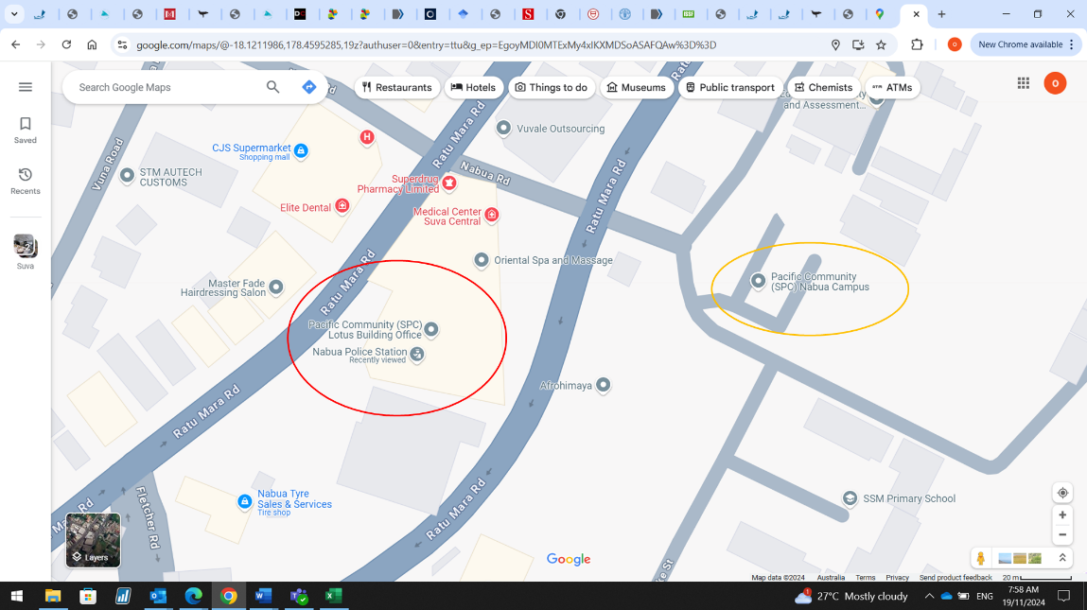

SPC has two campuses in Nabua. Our meeting is in the Lotus building (2nd Floor) (see red circle on screenshot). The Lotus building is above the Nabua police station. Entrance to the right of the police station entrance. If you get dropped off at the main campus (orange circle on screenshot) it’s a short 200m walk to the lotus building.

|  |
| --- |
| Agenda Item |
| 1. Introduction |
| 1. WCPFC Climate Indicators Overview    1. Indicator Framework    2. Candidate Regional Indicators |
| 1. Climate Indicators    1. Ocean State Reporting    2. National and Regional Ocean Indicators & Trends |
| 1. Fisheries Tuned Indicators    1. SDM    2. SEAPODYM    3. Fisheries    4. Decision related |
| 1. Framework for testing    1. Breakpoints    2. Track CC impacts    3. Empirical vrs Modelled |
| 1. Reporting    1. Met Services    2. Portals |

Tuesday 23rd November 2024, Fei Finomo Meeting Room Room, SPC Nabua (2nd Floor Lotus), Suva, Fiji, 9:30am-12:00pm

WCPFC Climate Indicators

|  |  |
| --- | --- |
|  | 1. Co-design/Resourcing    1. Collaboration network    2. Data Access |
|  | 1. Work plan |

## Workshop participants

|  |  |
| --- | --- |
| **Participant** | **Organisation** |
| Bernadette Sloyan | CSIRO, Australia |
| Bipendra Prakash | SPC, Fiji |
| Jone Amoe | SPC, Fiji |
| Naiten Bradley Phillip Jr | SPC, Federated States of Micronesia |
| Francis Tofuakalo | SPC, Solomon Islands |
| Nick Hill | SPC, New Caledonia |
| Simon Nicol | SPC, New Caledonia |
| Tuikolongahau Halafihi | SPC, New Caledonia |
| Victoria Pilbeam | SPC, New Caledonia |
| Lui Bell | SPC, Tonga |
| Lilis Sadiyah | NRIA, Indonesia |
| Fayakun Satria | NRIA, Indonesia |
| Emily Crigler | NOAA, USA |
| Felipe Carvalho | NOAA, USA |
| Ryan Rykaczewski | NOAA, USA |
| Pheobe Woodworth-Jercoats | NOAA, USA |
| Nicholas Ducharme-Barth | NOAA, USA |
| Glen Holmes | PEW, Australia |
| Johann Bell | Conservation International, Australia |
| Kara Miller | Conservation International, USA |
| Andrew Bassford | Marine Change, Hong Kong |
| Elaine Garvilles | WCPFC, FSM |
| SungKwon Soh | WCPFC, Federated States of Micronesia |